AADIGRA PVT LTD


PHASE-2 MARKET RESEARCH REPORT
Menstrual Wellness — India Market Intelligence

CAPSTONE REPORT
IIT Kanpur Capstone Project
Ayush Gupta | MBA 2nd Year
February 2026

Table Of Content

Section 1: Market Sizing — Bottom-Up Analysis
1.1 The Demand Foundation — What Phase-1 Tells Us
1.2 TAM (Total Addressable Market)
1.3 SAM (Serviceable Available Market)
1.4 SOM (Serviceable Obtainable Market)
Section 2: Competitive Landscape Analysis
Detailed Competitor Profiles
Section 3: Format Landscape — Where the Market Is Going
3.1 Existing product types in the category
3.2 Gaps and innovation opportunities-Product lens
Section 4: Pricing & Unit Benchmarks
4.1 Typical price points across competition
4.2 Mass vs premium positioning
4.3 Proposed Aadigra Pricing Architecture & Rationale
Section 5:Go-to-Market & Sales Strategies
5.1 Unit Economics — Channel by Channel
5.1 Distribution Roadmap
5.2 Marketing Strategy
5.3 Retention Architecture
5.4 Year 1 Launch Milestones
Section 6: Marketing Strategies Observed
6.1 Marketing Strategies Observed
Section 7: D2C Consumer Behaviour & Journey
Section 8: Market growth rates
Section 9:Key drivers
Section 10: Regulatory Framework
10.1 Product Classification
10.2 FSSAI Registration Pathway
10.3 Labelling Requirements
10.4 Ingredient Compliance
10.5 Advertising & Digital Marketing Compliance
10.6 IP & Brand Protection
Section 11: Consumer Usage Behaviour
11.1 High Symptom Burden, Low Structured Solution Usage
11.2 The Adherence Collapse
11.3 Preference for Personalised, Phase-Based Solutions
11.4 Trust in Purchase Behaviour
11.5 Price Sensitivity Patterns

Section 1: Market Sizing — Bottom-Up Analysis
The menstrual comfort products category in India sits at an unusual intersection: the problem is nearly universal, yet the formal market is barely 2–5% penetrated. This section builds a rigorous, bottom-up market sizing using two complementary lenses — the broader daily wellness supplements market in India, and the specific menstrual pain solutions sub-category that Aadigra is entering. All assumptions are anchored wherever possible in the Phase-1 primary survey findings (N = 313), supplemented by published industry sources.

1.1 The Demand Foundation — What Phase-1 Tells Us
Before sizing any market, it is worth establishing whether the problem itself is large enough to sustain a business. The Phase-1 survey answers that question unambiguously.

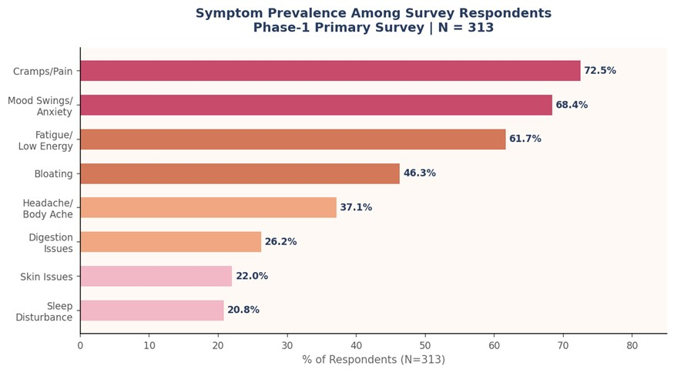
Figure 1.1 — Symptom Prevalence Among 313 Surveyed Women | Phase-1 Primary Survey, Feb 2026
93.6% of respondents reported at least one recurring menstrual symptom. Cramps and pain topped the list at 72.5%, but the data reveals something more important for product positioning: mood swings and anxiety (68.4%) and fatigue (61.7%) are nearly as prevalent as physical pain. The average woman in the sample reported 3.61 distinct symptoms per cycle — this is not a single-dimension pain problem. It is a multi-system disruption that recurs every month, without exception.
Of the 313 respondents, 71.2% reported moderate-to-severe disruption of daily life — work, study, sleep, or social activities affected. Yet when asked what they currently use to manage this disruption, the findings are striking.
46.3% of women use nothing specific — no product, no supplement, no structured approach. A further 27.2% rely on home remedies, and 21.4% reach for painkillers. Herbal or Ayurvedic products account for only 3.8% of current usage, and formal supplements for just 1.3%. This is the demand gap in its starkest form: over 60% of the country's women endure moderate-to-severe monthly disruption with no branded, structured solution.

1.2 TAM (Total Addressable Market)
Most of the percentage data used in this analysis is sourced from the World Bank 2024, and it is assumed that these percentages remain the same in 2026. According to the World Bank, 48.4% of India’s population was female in 2024, while in 2011 it was 48.5%, therefore, we assume the female population share to be 48.4% in 2026. With India’s total population at 1,476,625,576, the estimated female population becomes 714,686,778.8. From this, our target age group of 20–34 years constitutes 25%, giving a target base of 178,671,694.7 women. As per the World Bank, 35% of India’s population lives in urban areas, and we assume the same proportion applies to our target group, resulting in 62,535,093.14 urban women.

Based on our Phase 1 survey, 71.2% of respondents reported moderate to severe menstrual disruption, reducing the market size to 44,524,986.32 women. Of these, 51% showed high openness (ratings 4 and 5) toward personalised wellness solutions, leading to a Total Addressable Market (TAM) of 22,707,743.02 women.

 | Data | Sources
Total Population | 1,47,66,25,576 | Source
Female Population (%) | 48.40% | Source
Female Population (Figures) | 714686778.8
20-24 Female age group (%) | 9 % of Female Population | Source
25-29 Female age group (%) | 8 % of Female Population | Source
30-34 Female age group (%) | 8 % of Female Population | Source
Target Group (20 - 34) | 25 % of Female Population
Target Group (20 - 34) (Figures) | 178671694.7
Urban Population | 35 % of Female Population | Source
Female Urban Population (Target Group) (Figures) | 62535093.14
Moderate-To-Severe Menstrual Disruption | 71.20% | 44524986.32
Open to Personal Wellness | 51.00% | 22707743.02

Cost of AADIGRA Kit | ₹ 1200
No. of times purchased in a year | 3
Cost to customer (Annually) | ₹ 3600
Cost to customer (Monthly) | ₹ 300
TAM (Revenue Annually) | ₹ 8175 Crores

The cost of a kit is ₹1,200 per month. Assuming a customer purchases the product three times a year, their annual expenditure would be ₹3,600, which averages to ₹300 per month. Based on this, the total addressable market (TAM) revenue annually amounts to ₹81,747,874,880 (calculated as 22,707,743.02 potential customers × ₹3,600 per customer) ~ 8175 Crores.

1.3 SAM (Serviceable Available Market)
In our research with 313 respondents, 23% indicated a willingness to spend ₹900 or more per month. For estimating our Serviceable Available Market (SAM), we consider this 23% of the TAM. This approach highlights the segment of consumers who are ready to invest in a higher-value offering, reflecting a premium, engaged customer base, while acknowledging that in India, even if the average monthly expense is ₹300, a single upfront payment of ₹1,200 may be a barrier for some. The total
Serviceable Available Market (SAM) users are 5222781 and SAM revenue annually is ₹18,802,011,222, or approximately ₹1,880 crores.

SAM (Revenue Annually) | ₹ 1,880 crores
SAM (Users) | 5222781

1.4 SOM (Serviceable Obtainable Market)
Assuming the brand captures a 0.5% of SAM as market share within 2–3 years, the annual SOM revenue would be approximately ₹9.4 crore (₹94,010,056), corresponding to around 26,114 users.

Market Capture for New D2C wellness brand in 2–3 years | 0.50%
SOM (Revenue Annually) | ₹ 9.4 crore
SOM Users | 26114

Section 2: Competitive Landscape Analysis
The menstrual comfort products market in India is fragmented, young, and genuinely winnable. No single brand has established category leadership. The competitive field splits across four distinct archetypes — each with meaningful strengths and exposed gaps. This section maps every credible competitor, stress-tests their positioning against Phase-1 consumer data, and identifies the precise white space Aadigra can own.

46.3% women currently use nothing — the largest competitive opportunity | <5%  current branded supplement penetration of target women

Detailed Competitor Profiles
Each competitor is assessed across six dimensions: product depth, ingredient credibility, format appeal, trust architecture, pricing, and the specific gap they leave open for Aadigra.

Existing Players | What they solve | What they miss | Product  Format | Price | Positioning and core claims
Power Gummies  — "That Time of  The Month" | Reduces period pain & cramps; Helps with mood swings & bloating | Gummies have limited efficacy in fully relieving PMS or period symptoms; does not address sleep disturbances, anxiety, or skin issues | Chewable  Gummies | 800/unit (40 gums) | Improves Ovarian health to combat  PMS & PCOS  Symptoms
Kapiva Period  Care Juice | Supports menstrual health and helps combat period discomfort; boosts estrogen and provides hormonal balance | General support for hormonal balance, but not targeted at anxiety, sleep issues, skin problems, fatigue, or specific PMS symptoms | Juice | ₹550–599/ Bottle (1 litre) | 5 Ayurvedic Herbs  To Combat  Period Discomfort
NUA Period Pain  Relief Drink Mix | Gives relief from period cramps,  Helps relieve body ache | Focused on physical pain relief only; does not help with anxiety, sleep disturbances, or skin issues | Powder | ₹249/ Pack  (3 Sachet) | Period Nutrition Drink Mix for maximum  relief from period symptoms
Miduty Estrogen  Balance  Supplement | Supports  Hormonal Balance & helps with Menopause | Primarily focused on estrogen balance and menopausal symptoms; does not target anxiety, sleep, bloating, or fatigue | Capsules | ₹1306/Cont ainer (60  Capsules) | Clinically researched organic ingredients like to support overall menopausal health and ease related symptoms.
Namhya Women's  Health Tea | Regular period flow; regulates estrogen naturally; helps in weight management; prevents muscle  cramps | Does not specifically address anxiety, sleep, or skin issues; functional benefits are broad but lack focus | Tea | ₹589/ 30  Day Pack | Not just Tea, It's  Functional Healing

Other Brands
Existing Players | Strength | Price & Format | Positioning | What they miss
Dabur Ashokarishta | Provides relief from cramps and pain, Useful for digestive weakness  Improves appetite and digestion  Supports overall health and wellness | ₹175 / Bottle (450 ml syrup) | Relieves Menstrual Cramps &  Period Pain in  Women | Primarily focuses on pain and digestion; does not address hormonal imbalance,  PMS mood symptoms,
 |  |  |  | sleep disturbances, or skin issues
Zandu Ovoutoline  Forte | Supports hormonal balance, uterine health, and pre-menopausal symptoms (PMS) | ₹ 219 - 250/  Container (50  Capsules) | Ayurvedic Remedy  For Irregular  Menstruation  & Pre-Menopausal  Symptoms | Does not address sleep disturbances, or skin issues
Nari Jeevan Jyoti | Weak immune system,  Hormonal Imbalance,  Infertility | ₹ 4499 - 4999/  Container (60  Capsules) | Ensures Regular  Menstrual Cycle | Does not address period pain, mood swings,  sleep, or digestive health
Dr Vaidyas Period  Wellness | Helps Regulate Period  Pain, Cramps &  Controls Bleeding | ₹ 253 - 280/  Container (30  Capsules) | 17 all-natural and time-tested Ayurvedic ingredients for menstrual pain relief that help regulate monthly cycles by restoring hormonal balance | Focuses on pain relief and cycle regulation; limited attention to sleep, skin health, or fatigue  management

The heritage brands collectively own the mass market and pharmacy channel, but they are structurally weak in the urban 18–35 segment that Aadigra is targeting. Their formats (liquid tonics, churnas, classical tablets) do not match modern lifestyle compliance expectations. Phase-1 confirms that only 9.6% of respondents listed traditional formats as their preferred delivery mechanism — the format gap is structural and growing.

Section 3: Format Landscape — Where the Market Is Going

3.1 Existing product types in the category

Product Type /  Format | Brand & Product Name | Core Benefits | Observations
Chewable  Gummies | Power Gummies | Reduces cramps, mood swings, bloating | Convenient and tasty; limited efficacy in full PMS relief; doesn’t address sleep, anxiety, skin issues
Juice / Tonic | Kapiva Period Care Juice,  Dabur Ashokarishta | Hormonal balance, digestion, period discomfort relief | Focus on general wellness and hormonal support; limited symptom-specific targeting
Powder / Drink  Mix | NUA Period Pain Relief  Drink Mix | Relieves cramps, fatigue | Good for physical relief; lacks support for mood, sleep, skin, and hormonal balance
Capsules / Tablets | Miduty Estrogen Support,  Zandu Ovoutoline Forte, Dr  Vaidyas Period Wellness,  Nari Jeevan Jyoti | Hormonal balance, menopausal symptoms, fertility, cycle regulation | Clinically dosed; effective for targeted issues but narrow symptom coverage; sometimes high cost  (fertility/hormone-focused)
Tea | Namhya Women’s Health  Tea | Hormonal balance, period flow, muscle cramps | Functional and soothing; mild benefits; does not address mood, sleep, or skin issues
Syrups / Tonics | Dabur Ashokarishta | Pain relief, digestion, appetite | Traditional Ayurvedic approach; more holistic but lacks targeted PMS symptom coverage

3.2 Gaps and innovation opportunities-Product lens
Symptom / Benefit | Coverage | Gap Analysis
Period Pain & Cramps | Covered by most (gummies,  NUA, Dabur, Dr Vaidyas) | Coverage is mostly physical; mood, sleep, fatigue not addressed
Hormonal Balance /  Estrogen Support | Kapiva, Miduty, Zandu, Namhya | Good for hormonal regulation; not holistic—many don’t target PMS symptoms like bloating, anxiety, or skin issues
Mood & Anxiety | Power Gummies | Big gap—most products ignore emotional/psychological symptoms of PMS/menopause
Sleep Support | None | Opportunity to combine period/menopause relief with sleep benefits
Fatigue / Energy | NUA | Most products ignore this, despite common need during periods
Skin / Acne | Miduty, Power Gummies | Gap in managing hormonal skin issues during PMS/menopause
Digestive Support | Dabur , Power Gummies | Few products address this, though bloating and digestion  issues are common

Section 4: Pricing & Unit Benchmarks

4.1 Typical price points across competition
Product Type /  Format | Typical Price Range  (Monthly Usage) | Examples | Observations
Chewable Gummies | ₹550–599 / month | Power Gummies | Mid-range; targets convenience-focused, younger users; perceived as fun, easy-to-consume
Juice / Tonic | ₹175–₹249 / month | Kapiva Period Care  Juice, Dabur  Ashokarishta | Affordable/mass market; traditional Ayurvedic positioning; broader wellness appeal
Powder / Drink Mix | ₹249 / pack | NUA Period Pain  Relief Drink Mix | Premium; positioned for functional nutrition and targeted period relief
Capsules / Tablets | ₹219–₹4999 / month | Miduty Estrogen  Support, Zandu  Ovoutoline Forte, Dr  Vaidyas Period  Wellness, Nari Jeevan  Jyoti | Wide spectrum: mid-range for  PMS/menopause support (₹219–₹799), very premium for fertility/hormone-focused products (₹4499+)
Tea | ₹589 / 30-day pack | Namhya Women’s  Health Tea | Mid-premium; positioned as functional healing with wellness and hormonal balance focus
Syrups / Tonics | ₹175–₹250 / month | Dabur Ashokarishta | Mass market; trusted traditional Ayurvedic remedy; appeals to budget-conscious segment

4.2 Mass vs premium positioning
Segment | Price  Range | Format /  Examples | Key Positioning | Notes
Mass  Market /  Affordable | ₹175–₹2  50 /  month | Syrups, Juices  (Dabur  Ashokarishta,  Kapiva Juice) | General menstrual relief, digestion, wellness | Lower barrier to trial; limited symptom-specific claims; focuses on traditional remedies
Mid-Market  / Functional  Premium | ₹550–₹7  99 /  month | Gummies,  Capsules, Tea  (Power Gummies,  NUA, Miduty,  Namhya) | Multi-symptom support, functional nutrition, hormonal balance | Balances convenience, efficacy, and price; appeals to younger, health-conscious consumers
Premium /  Niche | ₹4499–4  999 / month | Specialized  Capsules (Nari  Jeevan Jyoti) | Fertility support, hormonal regulation, cycle optimization | High-value positioning; targets consumers with very specific health concerns; low trial volume due to price sensitivity

4.3 Proposed Aadigra Pricing Architecture & Rationale
Phase-1 validates a ₹300–400/month comfort zone for 37.7% of respondents and ₹500–600/month for 30.0%. The Discovery Pack at ₹299 sits below the first comfort threshold — eliminating price as a trial barrier. The single pack at ₹649 is priced above Power Gummies (₹599–749) to signal superior clinical credibility, while remaining below Miduty (₹850–1,200) to preserve volume accessibility.

Price resilience is strongest among the 28–32 age cohort (54.4% say price increase of 20% would not change their decision) — precisely the Modern Meera and Pragmatic Priya
segments. Price increases can be introduced from Year 2 without volume risk in this cohort.

SKU | Format | Price | Purpose | Target Segment  & Positioning
Discovery Pack | 15 effervescent tabs | ₹299 | Remove trial barrier; no  subscription required | Experimental  Eesha, Validator;  Mass Positioning
Single Pack | 30 effervescent tabs | ₹499 | Full-month supply; standard purchase | Modern Meera,  Pragmatic Priya;  Mass Positioning
Monthly  Premium | 30 Tablets with  (Personalised +  App ) | ₹899/month | To get premium customers | Pragmatic Priya, high-income Premium  Positioning
Monthly  Subscription | 30 tabs/month auto-renew | ₹449/month | Default for converted  customers; 15% saving | All segments post-trial Loyal  Customers  Positioning

Section 5:Go-to-Market & Sales Strategies

5.1 Unit Economics — Channel by Channel
Gross margin varies materially by channel. Digital-direct (D2C) is highest, but Amazon dominates Year 1 volume. The blended gross margin at a 50/30/20 channel mix (Amazon/D2C/Nykaa) is approximately 42–47%.

Cost Element | Amazon/Flipkart | D2C  Website | Nykaa | Notes
MRP(inc GST) | ₹499 | ₹499 | ₹499 | MRP on the product
MRP (excl. GST) | ₹445.54 | ₹445.54 | ₹445.54 | GST: 12% on supplements included in MRP display (₹499 shown to customer)
Platform/Marketplace  Fee | ₹80.20 (18%) | ₹22.28  (5%) | ₹62.38  (14%) | Amazon includes FBA +  referral
Shipping & Returns | ₹35.64 (8%) | ₹49.01  (11%) | ₹31.19  (7%) | Amazon FBA includes returns handling
COGS —  Manufacturing + Pkg | ₹97 (15%) | ₹97  (15%) | ₹97  (15%) | GMP contract manufacturer, 30-tab
COGS — Ingredients | ₹78 (12%) | ₹78  (12%) | ₹78  (12%) | At 500-unit/month volumes; reduces at scale
Gross Profit | ₹154.70 (31%) | ₹199.25  (40%) | ₹176.97  (35%) | Pre-marketing spend

47%  Blended Gross Margin  At launch channel mix (Y1) | 57%  D2C Gross Margin  Highest-margin channel | 55%+  Target Gross Margin  Year 3 at scale (D2C >40%)

5.2 Distribution Roadmap
Year 1 distribution is intentionally focused on digital-first channels to enable rapid feedback loops, review accumulation, and customer data ownership. Offline expansion enters in Year 2 via pharmacies and modern trade, where doctor-pull creates demand ahead of push.

Channel | Year 1 Share | Year 3 Share | Rationale
Amazon / Flipkart | 50% | 40% | Volume + reviews; dominant discovery for health supplements
D2C Website | 30% | 25% | Highest margin; enables subscription; customer data ownership
Nykaa / Health platforms | 15% | 15% | Female-first audience; brand positioning uplift
Pharmacy (offline) | 0% | 10% | Doctor-pull strategy; credibility signal; enter  Year 2
Modern Trade / Retail | 5% | 10% | Tier-2 city reach; enters post-₹5 Cr ARR milestone

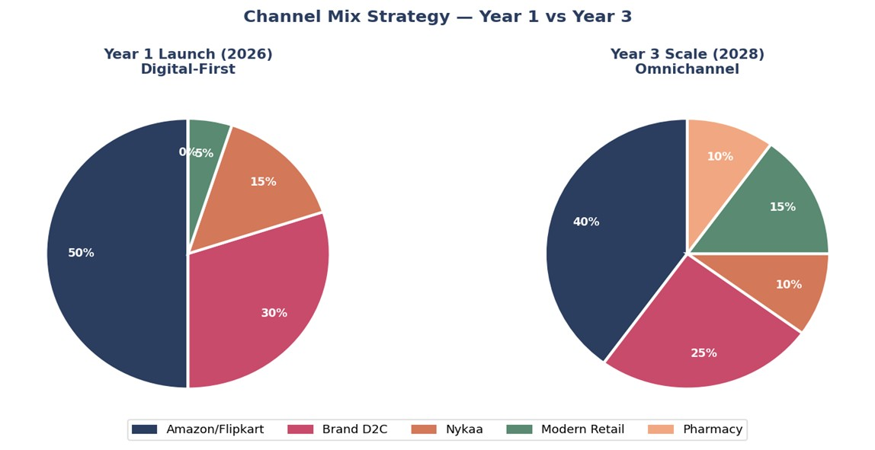
Fig 4.1 — Channel mix evolution: Year 1 vs Year 3

5.3 Marketing Strategy
The Aadigra marketing playbook inverts the typical D2C approach. Instead of leading with social media reach and chasing credibility retrospectively, Aadigra builds medical credibility first through doctor outreach, then amplifies authentic user outcomes through micro-influencers, with performance marketing as the scaling engine.

Channel | % | Year 1 Objective | KPI | Phase-1 Justification
Performance  Marketing | 35% | Paid acquisition: awareness to trial conversion | CAC < ₹800; ROAS > 2.5x | Industry-standard 30–40% for early D2C. Scales what the credibility channels build.
Micro-influencers  (10K–100K) | 25% | Authentic peer outcomes;  trust-building content | 100 creators;  50M  impressions | Real user outcomes ranked  #4 trust factor (47%). Peer voices outperform macro reach for this audience.
Doctor Outreach  Programme | 15% | Medical endorsement  pipeline; trust anchor | 150 gynaecologists engaged | Doctor recommendation = #1 trust factor at 65.5%.  Disproportionate allocation vs industry norm — justified by survey.
Content / SEO | 15% | Organic discovery; long-tail symptom queries | 20 articles; 50K monthly visits | 54.3% drop off before Day  10 — they researched but weren't convinced. Content captures this pre-trial research intent.
Macro-influencers | 5% | Brand awareness spikes at launch only | 2–3 women's health creators | Social media influencers ranked last at 4.5% trust.  Minimal budget reflects this — reach not credibility.
PR / Sampling | 5% | Earned media; opinion leader seeding | 15 placements;  500 samples | Safety & compliance assurance = #2 trust factor  (52.1%). Third-party editorial coverage signals legitimacy.

5.4 Retention Architecture
Given the 54.3% Day-10 drop-off pattern, retention is not a post-launch consideration — it is a product design input. The following mechanisms are built into the Aadigra customer experience from Day 1:

Mechanism | Timing | Goal
Subscription as default checkout | At purchase | Reduce churn friction; increase  LTV from first order
Cycle-synced  SMS/WhatsApp reminders | Day 21–25 of cycle | Prompt pre-period consumption; close the compliance gap
5-part email welcome flow | Days 1, 3, 7, 14, 30 | Educate on ingredients; set outcome expectations; collect  feedback
First-result check-in | Day 10 | Acknowledge early change; prevent quitter behaviour
Referral programme | Day 30+ | Referral Vouchers ; convert satisfied customers to advocates
Loyalty points | Every order | Gamify subscription continuity; reinforce habit

5.5 Year 1 Launch Milestones
The launch timeline is sequenced to build credibility assets before scaling spend. The first 60 days are pre-launch: formulation finalisation, regulatory filing (FSSAI), doctor outreach seeding, and micro-influencer onboarding. Revenue scaling begins in Month 3.

Phase | Timeline | Milestone | Revenue Target
Pre-Launch | Month 1–2 | FSSAI filing; 10 doctor samples; 8–10 micro-influencers; D2C waitlist of 200+ | —
Launch | Month 3 | Amazon + D2C live; 80–120 orders; first  20–30 reviews | ₹1–6L
Early Traction | Month 4–6 | 300–500 customers/month; 60–80 reviews;  20–25% repeat rate | ₹4–12L/mo
Stabilisation | Month 7–9 | 800–1,200 customers/month; 150+ reviews; subscription rate 20%+; Nykaa listing initiated | ₹10–25L/mo
Year-End | Month 10–12 | 1,500–2,500 customers/month; 250+ reviews; doctor outreach showing early pull | ₹18–40L/mo

Section 6: Marketing Strategies Observed

6.1 Marketing Strategies Observed

Analysis of comparable Indian D2C women's health brands (Nua, Plix, Kapiva, Power Gummies) reveals five consistent marketing strategies deployed at early stage.

Strategy | What Observed Brands  Do | Data Point | Aadigra Application
Influencer marketing | Micro-influencers  (10K–100K) used for trust-building; macro for awareness spikes at launch only | Real user outcomes =  47% trust driver  (Phase-1); social media influencers = only 4.5%  [Phase-1] | Lead with micro; macro is residual 5% of budget
Content & SEO | Symptom-led blog content targeting long-tail search queries drives  lowest-CAC organic  traffic | Organic CAC is 5–7x lower than paid over time; online  supplements growing  15% CAGR | 20 high-intent symptom articles; target 50K  monthly visits by  Month 12
Performance marketing | Meta + Google = 30–40% of Year 1 budget for D2C health; rising ad costs  require organic balance by Month 6 | India ecommerce projected USD 200B by 2026 at 18.7% CAGR  [14] | 35% budget; scale only after CAC < ₹1,000 is  proven
Medical education | GPs and gynaecologists briefed with clinical  summary cards; non-paid, trust-based; used by Kapiva and herbal supplement brands | Doctor recommendation = #1  trust factor at 65.5%  (Phase-1) | 100–150 gynaecologists in Y1; highest ROI trust channel available
Community  building | WhatsApp groups, subscription loyalty, cycle  reminders; non-discount  retention outperforms coupon-only | Loyalty programme →  43% repeat purchase increase; 5% retention  lift → 25–95% profit  lift | Cycle-synced reminders  + referral ₹100/₹100 from Day 1

Section 7: D2C Consumer Behaviour & Journey

Stage | Observed Behaviour | Key Friction | Aadigra Response
Discovery | Symptom search on  Google; Instagram Reels and short-form content  dominate first exposure;  54% still rely on physical stores initially | Low brand awareness for new D2C;  consumers default to established names | SEO for symptom queries + micro-influencer reels;  doctor name-drop in  content
Consideration | Price comparison on  Amazon, D2C site,  Nykaa; review reading; ingredient checking  increases with education  level | Consumers see new  D2C supplements as expensive vs OTC alternatives | Discovery Pack ₹299 removes price barrier;  doctor signal accelerates  conversion
First Purchase | Amazon preferred for first purchase from  unknown brands (return  policy trust); Metro skews  UPI; Tier-2/3 still 70%  COD | COD returns are high cost; Amazon fees eat  margin | Amazon as first-purchase channel; D2C site as subscription home
Repeat &  Subscription | Repeat driven by results visibility + habit  formation; subscription  trust takes 2–3 cycles to  build | 54.3% drop off by Day 10 — most customers don't reach the repeat window (Phase-1) | Effervescent ritual + Day 7 outcome SMS closes the  Day 10 gap
Advocacy | WhatsApp sharing,  Amazon review posting,  Instagram story tagging;  NPS-driven word-of-mouth | Reviews take 3–4 months to accumulate; referral only works after NPS is positive | Referral programme activated at Month 2;  review request automated  post Day 14

Section 8: Market growth rates
India women's wellness, nutraceuticals, and preventive healthcare are three of the highest-growth sub-sectors within India's broader health economy. The figures below are sourced directly from IMARC Group's 2025 reports and Kalaari Capital's India preventive healthcare analysis.

11.14%  India Nutraceuticals CAGR  2026–2034 · IMARC [1] | 7.70%  India Women's Health CAGR  2025–2033 · IMARC [2] | 22%  India Preventive Healthcare CAGR  2021–2025 · Kalaari / Statista [3]

Market | Base Year  Value | Base  Year | Projected  Value | Projection  Year | CAGR | Source
India  Nutraceuticals | USD 8.93  Billion | 2025 | USD 23.09  Billion | 2034 | 11.14% | [1]
India Women  Health &  Wellness | USD 4.66  Billion | 2024 | USD 9.58  Billion | 2033 | 7.70% | [2]
India  Preventive  Health-Tech | USD 93 Billion | 2021 | USD 197 Billion | 2025 | ~21% | [3]
Preventive  Healthcare  (broad) | — | — | USD 532 Billion | 2030 | 22% | [4]
India Women's  Hygiene | USD 1.56  Billion | 2024 | USD 3.15  Billion | 2030 | 15.1% | [5]

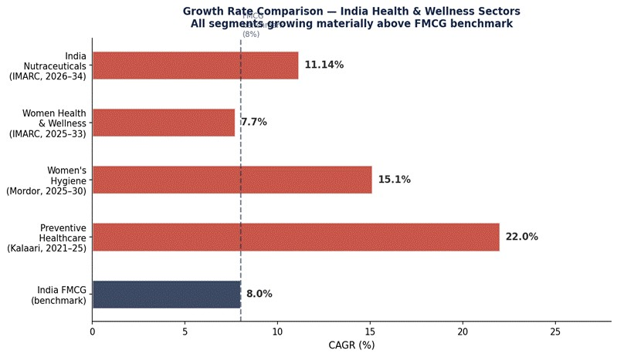
Fig 6.1 — CAGR comparison across India health & wellness segments vs FMCG benchmark (8%) · Sources: IMARC , Mordor, Kalaari

India Nutraceuticals Market
India's nutraceuticals market was valued at USD 8.93 billion in 2025 and is projected to reach USD 23.09 billion by 2034, growing at a CAGR of 11.14% from 2026–2034 (IMARC Group, 2025). Growth is driven by rising health consciousness, expansion of online distribution channels, and India's structural preference for plant-based and Ayurvedic supplement formulations.

Sub-segment relevance: The dietary supplements sub-category — which includes Aadigra's product type — is among the fastest-growing within nutraceuticals. Online channels are growing at 15% CAGR, directly benefiting a D2C-first launch strategy. Plant-based nutraceuticals dominate both by preference and CAGR, validating the Ayurvedic formulation core in Aadigra's product.

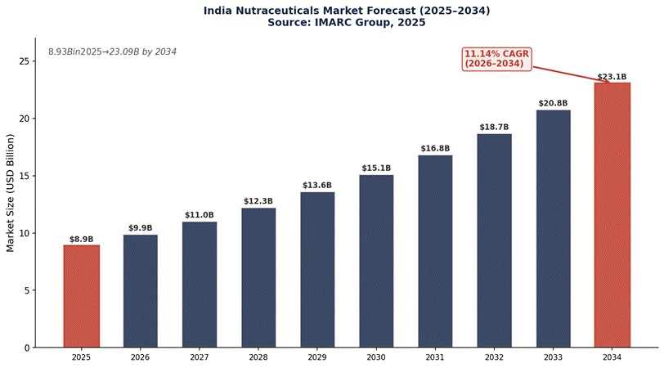
Fig 6.2 — India Nutraceuticals Market: USD 8.93B (2025) → USD 23.09B (2034) at 11.14% CAGR · Source: IMARC Group

India Women Health & Wellness Market
India's women health and wellness market reached USD 4.66 billion in 2024 and is expected to reach USD 9.58 billion by 2033, at a CAGR of 7.70% during 2025–2033 (IMARC Group, 2025). The market encompasses four segments: FemTech (Female Technology), Health and Beauty Supplements, Preventive Healthcare and Holistic Wellness, and Beauty and Personal Care.

The market is experiencing significant growth, driven by increased awareness, digital health adoption, and rising demand for natural products. E-commerce and urbanisation further accelerate market expansion across the country. The Health & Beauty Supplements and Preventive Healthcare segments are the most directly relevant to Aadigra — these two segments are growing faster than the overall 7.70% market CAGR as consumers increasingly invest in proactive wellness.

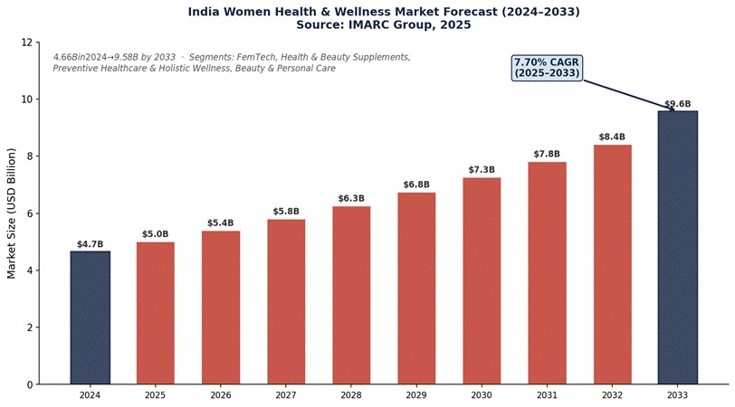
Fig 6.3 — India Women Health & Wellness: USD 4.66B (2024) → USD 9.58B (2033) at 7.70% CAGR · Source: IMARC Group [2]

India Preventive Healthcare
Preventive healthcare is India's fastest-growing health sector. According to Kalaari Capital's analysis, the sector is projected to reach USD 532 billion by 2030 at a CAGR of 22% — surpassing the curative (treatment) market's growth rate of 15%. The preventive health-tech sector alone grew from USD 93 billion in 2021 and is estimated to reach USD 197 billion by 2025 at a 21% CAGR.

The COVID-19 pandemic was a structural inflection point. A Kalaari Capital survey shows that 70% of Indians now prioritise overall health and precautionary measures in their daily routines. By 2026, a doubling in per capita spending on health foods is anticipated, with consumers showing willingness to pay more for preventive and wellness products. The healthy food and nutrition market — Aadigra's direct adjacent space — is projected to expand to USD 30 billion by 2026.

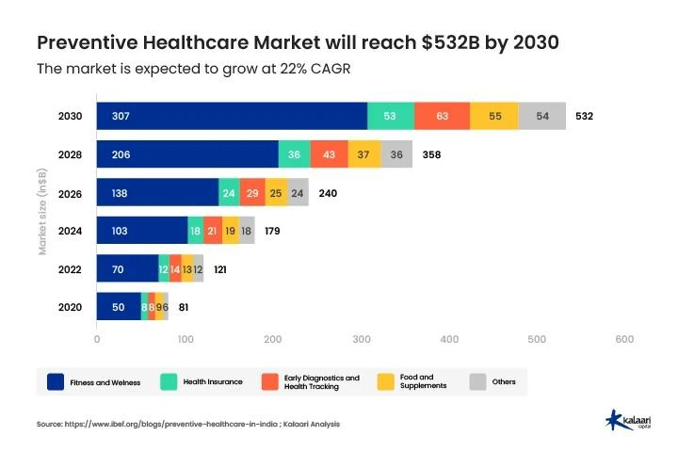
Fig 6.4 — India Preventive Healthcare: USD 93B (2021) → USD 197B (2025) at 21% CAGR, projecting USD 532B by
2030 · Source: Kalaari Capital [4], Statista [3]

Section 9:Key drivers

Five macro forces are simultaneously expanding the opportunity for Aadigra. Each is backed by published data and has a direct implication for product positioning, channel strategy, or marketing approach.

01 | Urbanisation & Rising Disposable Income  · 35% of India's population is urban (World Bank, 2024); target cohort (women 20–34) skews higher  · Urban women show the highest supplement adoption rates and strongest online purchase intent  · India's urban middle class projected to reach 583 million by 2025 (McKinsey)  · Aadigra TAM filtered to urban target group: 6.25 Cr women (Section 1) | Aadigra implication  Metro and Tier-2 urban as Year 1 target. Tier-3 viable only after pharmacy channel in Year 2–3, when reach infrastructure is in place.

02 | D2C Boom & E-Commerce Penetration  · India D2C market growing at ~39% CAGR through  2032 (Coherent Market Insights)  · Online-only D2C brands hold 63.9% of India's BPC market in 2025  · Online supplement distribution growing at 15% CAGR through 2030 (MoFPI)  · 78% smartphone penetration in Tier-2/3 cities (2024) makes D2C viable beyond metros  · Amazon India is the top first-purchase channel for unknown supplement brands | Aadigra implication  D2C + Amazon as primary channels from Day 1. Low capital requirement relative to offline. Review velocity on Amazon is the fastest trust-building lever available at launch.

03 | Health Awareness & Preventive Mindset Shift  · 70% of Indians now prioritise preventive health in daily routines — up from <40% pre-2020 (Kalaari)  · 640 million+ Indians used nutraceuticals for the first time during COVID-19 (DataM Intelligence)  · Preventive healthcare growing at 22% CAGR, outpacing curative market at 15% (Kalaari)  · Healthy food & nutrition market projected at USD 30B by 2026 (Kalaari)  · Phase-1: 93.6% of respondents report ≥1 menstrual symptom; 71.2% report moderate–severe disruption | Aadigra implication  Position as a preventive daily habit, not a treatment. Messaging: 'your daily wellness ritual' resonates more than symptom-crisis language with this educated, urban consumer.

04 | Regulation Tightening (FSSAI 2022)  · FSSAI FSS (Nutraceuticals) Regulations re-operationalised October 2022 — tighter than 2016 framework  · Disease treatment claims now actively penalised — up to ₹10L under Section 53, FSS Act  · Many small D2C competitors remain non-compliant on labelling and ingredient disclosure  · Stricter labelling requirements create a credibility floor that favours transparent brands  · CDSCO reclassification risk for high-potency products making drug-like claims | Aadigra implication  Early FSSAI compliance is a competitive moat. Aadigra's ingredient dose transparency on label is a differentiator most competitors avoid — and the 2022 framework now rewards it.

05 | Trust Shift: Medical Credibility Over Social  Reach  · Phase-1 (N=313): Doctor recommendation = #1 trust factor at 65.5%  · Phase-1: Social media influencers = #7 (last place) at only 4.5%  · Phase-1: Safety & compliance assurance = #2 trust factor at 52.1%  · Phase-1: Clinical validation = #3 trust factor at 48.3%  · D2C brands report consumers comparing new brands unfavourably to established names on trust (BW  Healthcare) | Aadigra implication  Doctor outreach programme is non-negotiable before scaling paid ads. Budget allocation reflects this: 15% to medical education vs 5% to macro-influencers — directly inverted from D2C convention.

All five drivers converge on the same strategic brief: Aadigra is entering a market that is structurally growing, digitally accessible, trust-hungry, and about to be cleaned up by regulation. The brand that gets credibility right first wins disproportionately.

Driver | Key Data Point | Trend | Source
Urbanisation | 6.25 Cr urban women aged 20–34 in target group | 35% urban → 40%+ by  2030 | World Bank 2024 [1]
D2C boom | 63.9% of India BPC market held by online-only D2C brands | 39% CAGR through  2032 | Coherent Market [2]
Health awareness | 640M+ first-time nutraceutical users during COVID-19 | Preventive CAGR 22% vs curative 15% | DataM [3], Kalaari [4]
Regulation tightening | Disease claims now penalised up to  ₹10L — FSSAI 2022 | Stricter enforcement expected 2025–27 | FSSAI [5]
Trust shift | 65.5% cite doctor rec. as #1 trust driver (Phase-1, N=313) | Influencer trust declining in health category | Aadigra Phase-1 [6]

Section 10: Regulatory Framework

India's regulatory environment for wellness supplements is navigable but operationally complex. Getting it right from Day 1 is essential — both to protect the business and to use compliance as a credibility signal. This section covers FSSAI licensing, labelling requirements, permitted claims, ingredient compliance, and the timeline to first sale.

10.1 Product Classification
The critical first decision is product classification, which determines the regulatory pathway, permitted claims, and labelling standards. Aadigra's effervescent supplement qualifies as a Health Supplement under FSSAI regulations — a classification that allows structure-function claims without the requirement for drug licensing or clinical trial data submission.

Classification | Governing Reg. | Permitted Claims | Aadigra Applicable?
Health Supplement | FSS (Health Supplement,  Nutraceuticals) Regulations  2022 | Structure-function claims  (e.g., 'supports menstrual comfort') | YES — primary classification
Nutraceutical | FSS (Health Supplement,  Nutraceuticals) Regulations  2022 | Similar to Health  Supplement; specific nutrient thresholds | Possible for vitamin-mineral components
Ayurvedic  Proprietary  Medicine | Drugs & Cosmetics Act  1940 (AYUSH) | Broader therapeutic claims; Ayurvedic ingredient combinations | Optional — parallel registration for legacy  herbs
Drug / OTC  Medicine | Drugs & Cosmetics Act  1940 | Disease treatment and prevention claims | NOT applicable — would require clinical  trial data

10.2 FSSAI Registration Pathway
FSSAI registration for health supplements follows a defined pathway. Aadigra should pursue a Central FSSAI License (required for manufacturers and distributors operating across states) and file from Day 1 of company incorporation to hit the 14–21 week timeline.

Step | Activity | Timeline | Key Output | Critical Dependency
1 | Formulation lock & ingredient GRAS verification | Weeks 1–4 | Final formulation spec; ingredient compliance memo | Identify  FSSAI-approved ingredients list
2 | FSSAI Central  License application  (Form B) | Weeks 3–8 | FSSAI application submitted; reference number | GMP manufacturer address required at  filing
3 | GMP contract manufacturer audit & agreement | Weeks 4–8 | Manufacturing agreement; GMP  certificate | Must be Schedule M compliant
4 | Product testing at  NABL-accredited laboratory | Weeks 8–12 | CoA (Certificate of  Analysis); heavy metal test | Required before label approval
5 | Label artwork finalisation and print | Weeks  12–16 | Print-ready label; compliance checklist signed off | All claims reviewed  against permitted list

10.3 Labelling Requirements
FSSAI's labelling standards for health supplements are detailed and non-negotiable. Violations at point of sale can result in product recall, penalties, and brand damage. The key mandatory elements are outlined below.

Label Element | FSSAI Requirement | Aadigra Application
Product name | Must not imply disease treatment | "Aadigra — Menstrual Wellness Supplement"
Nutrition information | Per serving and per 100g; standardised format | Per tablet (one serving): all ingredients with doses
Ingredient declaration | In descending order of weight | Ginger 500mg > Curcumin 300mg > Shatavari 300mg...
Recommended daily allowance | If claiming % RDA, must cite  Indian RDA | Magnesium: 200mg = 50% of Indian RDA  (400mg)
Directions for use | Mandatory; must be clear | "Dissolve 1 tablet in 200ml water. Take once daily."
Advisory & caution | Mandatory for health supplements | "Consult a physician if pregnant, nursing, or on medication."
FSSAI license number | 14-digit FSSAI number on all packaging | License number displayed on back panel
Batch number & expiry | Mandatory | Batch/LOT + Mfg date + Best before date
Net contents | Weight or volume | "30 effervescent tablets | Net Wt: 90g"
Country of origin | Mandatory | "Made in India"
Customer care details | Name, address, and customer care contact | Brand registered address + helpline number

10.4 Ingredient Compliance
All ingredients must appear on FSSAI's approved ingredient list for health supplements. The Aadigra formulation uses well-established ingredients, but dosages and form specifications require verification against the latest FSSAI permitted limits.

Ingredient | FSSAI Status | Max Permitted Dose | Aadigra  Dose | Compliance Status
Ginger Extract  (std.) | Permitted —  Annexure I | No upper limit specified; RDI guidance applies | 500mg/tab | Compliant
Curcumin (95%  extract) | Permitted —  Annexure I | 1000mg/day max  (WHO guideline) | 300mg/tab | Compliant
Shatavari (Asparagus racemosus) | Permitted —  AYUSH  approved herb | Traditional use dose; no FSSAI upper limit | 300mg/tab | Compliant — verify via AYUSH list
Ashwagandha  KSM-66 | Permitted —  Annexure I | 600mg/day commonly cited in  literature | 200mg/tab | Compliant
Magnesium  (Glycinate form) | Permitted —  Mineral supplement | 340mg/day (FSSAI  upper limit) | 200mg/tab | Compliant
Vitamin B6  (Pyridoxine HCl) | Permitted —  Vitamin supplement | 25mg/day (FSSAI upper limit) | 10mg/tab | Compliant

10.5 Advertising & Digital Marketing Compliance
FSSAI's advertising standards for health supplements restrict promotional content to the same claims framework as product labelling. Social media, influencer partnerships, and digital ad creative must all be reviewed before publication. Key rules include:

Medium | Regulatory  Body | Key Restriction | Aadigra Requirement
Product packaging | FSSAI | No disease claims; must include advisory text | Legal review of all panel text before print
Social media  (brand page) | FSSAI + ASCI | No unverified efficacy claims; ASCI Code of Self Regulation | Monthly content audit; claims library pre-approved
Influencer / UGC content | ASCI + SEBI  Guidelines | Paid partnerships must be disclosed (#ad, #collab) | Contract clause: all creators must disclose + stay within  claims brief
Performance ads  (Google/Meta) | FSSAI +  Platform policies | Meta restricts 'before/after' imagery for health products | Creative guidelines: outcomes-focused, no transformation imagery
Amazon product  listings | Amazon health supplement policies | Cannot claim to treat, cure, or prevent disease | A+ content reviewed against  FSSAI claims list

10.6 IP & Brand Protection
Parallel to FSSAI registration, Aadigra should pursue trademark registration for the brand name, logo, and product names under Class 5 (pharmaceuticals and supplements) and Class 3 (cosmetics, if applicable). This is a 18–24 month process but provides critical protection against copycat products, particularly as the brand gains traction.

IP Asset | Registration Body | Timeline | Priority
Brand name  'Aadigra' | IP India (Trademark  Registry) | 18–24 months  (Class 5) | HIGH — file immediately
Logo / wordmark | IP India (Trademark  Registry) | 18–24 months (Class 5 & 16) | HIGH — file with brand name
Formulation (trade secret) | Internal NDA + supplier agreements | Immediate | MEDIUM — protect via contracts, not patent
Domain names  (aadigra.in, aadigra.com) | NIXI / domain registrar | Immediate | HIGH — register before launch
Social handles | Instagram, Facebook,  YouTube, LinkedIn | Immediate | HIGH — claim all handles now

Section 11: Consumer Usage Behaviour
(This is based on Phase 1 Survey Data)
11.1 High Symptom Burden, Low Structured Solution

Usage
The survey reveals that 71.2% of women experience moderate to severe menstrual disruption, with an average of 3.61 concurrent symptoms per person, spanning physical pain, emotional instability, fatigue, and bloating. Despite this high burden, 46.3% of respondents use no structured solution at all, indicating a large unmet need gap.
This gap exists not due to lack of motivation, but due to solution inadequacy and behavioural friction.

11.2 The Adherence Collapse
Only 17.9% of women maintain wellness routines for more than 21 days per month, while 54.3% drop off within the first 10 days. This creates an 82.1% adherence failure rate, driven by:
- Busy routines (60.4%)
- Forgetting (54.3%)
- Fear of side effects (20.1%)
- Lack of visible benefit (19.8%)
This highlights that habit failure—not symptom absence—is the central consumption barrier.

11.3 Preference for Personalised, Phase-Based Solutions
A strong 75.4% of women believe different menstrual cycle phases require different bodily support, while 50.6% are open to personalised wellness solutions, signalling a high conceptual readiness for Aadigra’s system approach.
However, current market offerings remain single-point symptom solutions, failing to align with this cognitive expectation.

11.4 Trust in Purchase Behaviour
Trust acts as the primary purchase gatekeeper:
- Doctor recommendation: 65.5%
- Safety & compliance assurance: 52.1%
- Clinical validation: 51.4%
This establishes that medical credibility and regulatory transparency directly drive trial, repeat, and long-term adoption.

11.5 Price Sensitivity Patterns
Price sensitivity is driven by geography and life stage, not perceived need. Metro professionals show higher willingness to pay (₹900–1,000/month), while Tier 2 consumers cluster around ₹300–400/month, validating Aadigra’s tiered pricing strategy.

